Day 7 – Dynamic Small Business Search

We are going to scour DSBS (dynamic small business search) for companies in our market who are at the top of their game. We are looking for the industry unicorns.

This technique works well when you need partners, mentors, or looking at subcontract opportunities. The companies that we identify will have tons of work and more than likely have a subcontractor database already in place.

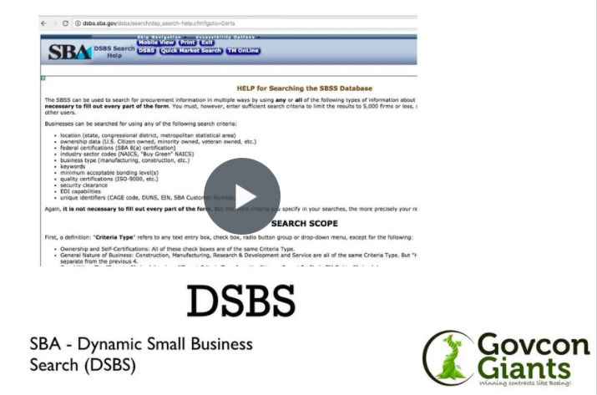

Find your future Team/JV Partner now!

For the HW assignment today we will be using two (2) approaches to leveraging DSBS. Approach #1 – becoming a subcontractor, looking for work and approach #2 building a team to pursue specific opportunities.

This is the basis for building a hockey stick business.

Best of luck,

Eric Coffie

